Ammar Ahmed BDS2B2
20L-0961
Lab 8 Tasks

Question 1:
4x1 mux using:
1x 2x4
4x AND
3x OR.
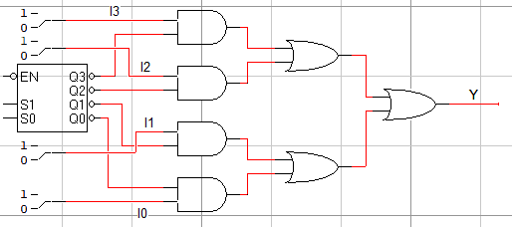

Question 2:
F (X, Y, Z) = m₁ + m₂ + m₆ + m₇
Using 4x1 mux:
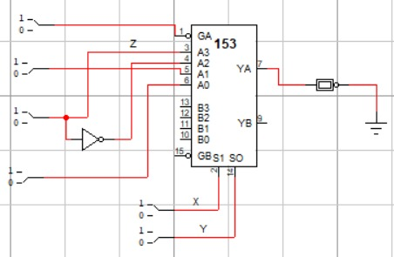
Question 3:
2-Bit Multiplier
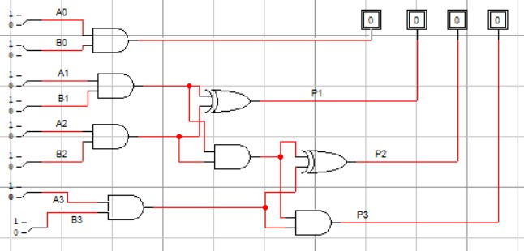

POST LAB
Question 4:
4x1 mux using two 2x1 muxes.
